Test 1 Lecture 1
Wednesday, January 09, 2008
9:16 AM

Midterm and Final only grades 50% each

Study of how the body moves

Start w/ what do we build it out of

Most of this should be a review of path, physiology, and anatomy

We will be talking about stress and strain first

What is stress?
A force applied to something
Depending on the surface area we apply it over we will vary the stress

Example: a 10k lbs elephant steps on you vs a 100 lbs woman steps on you
The elephant steps on you w/ a 10x10 area
Divide that and get 100 lb/sq in (half that b/c they will have at least 1 other foot down)
The female will have a small heal on w/ an area of 1/2 in square we get 400 lbs/sq inch

What is strain?
When we apply stress on something
Strain rate=amount of deviation of object to which force is applied
A typical ligament has a 3% strain rate before damage occurs
We plot strain (X axis) vs stress (Y axis)
The straight portion of the curve is the elastic portion, then the curvature is the plastic portion (I, II), then we have failure at the end (III)
The area under the curve of the elastic portion is stored energy but some of that energy is lost (hysteresis)
Hysteresis=energy loss during elastic portion of strain, stress curve

When stress testing objects we have 3 curves. A has a steep slope (it is stiff), B has a shallower slope, and C has a almost flat slope (it is the most elastic). The strongest one will be the one which goes the highest (on the Y axis) before failure. Ligamentum Flavum would be most like C.

Another test (bending a bone until it breaks). B is being bent fast and will fail at a lower level, this will appear as a total fracture w/ damage to surrounding tissue. A is being bent slower and will fail at a higher level, this will appear as a small linear fracture w/ no damage to surrounding tissue. Only works for living tissue.

Young's Modulus=slope of elastic portion stress curve
Creep=continual stress placed upon the body

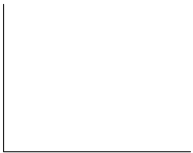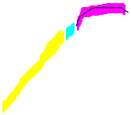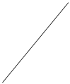

Grade (Amount of tissue damage) | Clinical findings | Healing time
I  (Mild) | Simple strain/sprain  1-10% fibers damaged  Uncomplicated, trigger points, some loss of ROM, small fiber damage  Minimal pain, splinting, minimal palatory pain  Fixation and decreased joint play in spine | 1-> 4 weeks
II  (Moderate) | Moderate strain/sprain partial tearing of ligaments or muscle, hemorrhage, marked pain & splinting  11-50% fiber damage  Athletic injury, lifting, trauma  Same clinical picture as above but more severe | 2 weeks-> 1 year
III  (Severe) | severe strain/sprain-may be complete laceration  Complete separation of origin and insertion  51-100% fiber damage  Ecchymosis/bruising, marked dysfunction, palpate damage  Refer for surgical evaluation | 2 months-> over 1 year

Lecture 2
Friday, January 11, 2008
9:08 AM

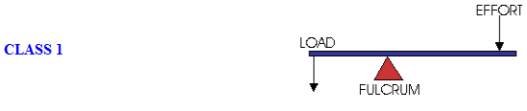

"If you give me a lever long enough and a fulcrum on which to place it I could move the world"-Archimedes

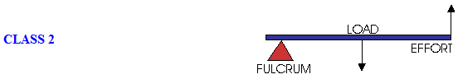

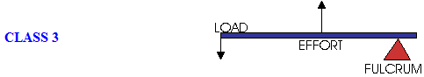

Lever systems

Levers of the body produce forces which creates movement

Fulcrum=point of rotation of a lever (joints in the body)

3 classes
Type I
Fulcrum w/in middle of lever (balancer)
The fulcrum must resist the forces placed on both ends of the lever (by bringing the load closer to the fulcrum we reduce the effort required to lift the load and also reduce the force placed upon the fulcrum)
Disc/Ankle/Atlas-Occiput

Forces at the head/neck
10 lb head w/ center of gravity is through the condyles
10 lb head tilted forward (4" lever arm) is opposed by the sub-occipital muscles (1" lever arm) which must exert 40 lb of resistance to keep the head forward

Force during whiplash
When the head comes forward (6") under extreme force (10 G) a larger force is placed on the sub-occipital muscles (600 lb). The Occiput is forced to support the increased load (700 lb).
Type II
Fulcrum is at the end of the single lever arm. Load is placed proximal to the fulcrum than the effort input
Mechanical advantage give by increased lever arm for the effort.
Disadvantage=shorter ROM
Type III
Fulcrum is at the end of the single lever arm. Load is placed distal to the fulcrum than the effort input
Mechanical disadvantage is increased effort required for motion
Advantage=a greater range of motion is produced

The moment arm=the distance b/t the fulcrum and the load/effort

Lecture 3
Wednesday, January 16, 2008
9:17 AM

Lets start looking at the strength and weakness of bone
Why do we have bones?
Protection, mineral stores, provide support, provide levers for muscular attachment, make RBCs
Flat bones make RBCs and provide protection
Weaknesses=tumor metastasis sites
Density differences b/t cortical and trabecular bone result in different strengths
Composite composition allows for added capability (collagen for tensile strength, hydroxyapatite for compression)
Lets see what else we see
What are the 3 pathological conditions related to bones we will see most?
Osteoporosis, fracture, tumors
Fractures
Bones break due to bending primarily
Bone healing takes different times to heal depending on age/sex/other factors
3 things you need to do to a broken bone
Stabilize, vascularize, set
Blood vessels are sent in by nearby soft tissue (muscle) after break
Most common fracture we will see: pars interarticularis
Spondylo
Pars fracture-can heal
Typically occur under age of 4 (rare after 18)
Hyper flexion/extension most common cause
Fractures (why does bone take so long to heal?)
Rib, b/c it is always moving
Transverse Patella, separates two parts
Scaphoid, 70% of carpal bone fractures, b/c of low blood supply
Distal ankle, b/c of low/unidirectional blood supply
Femur neck, blood supply difficult b/c capsule covers this
Vertebral End Plate Fractures, constant compression may continue to degrade
Heel fractures/Calcaneus, constant compression/changing the orientation of the bone

Fractures that move a lot we will get an enlarged callus forms at the area moment of inertia (where material is placed further from central break point to increase stiffness)

The good news is that bone fractures will completely regenerate

Stress fracture
March fracture=metatarsal fracture due to increased weight under repetitive stress during marching
Strenuous exercise->fatigue muscle->loss of shock absorption->high tension->transverse cracks->transverse fractures
Transverse Patellar fracture
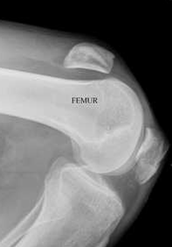
Femur neck fracture
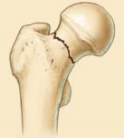

Lecture 4
Friday, January 18, 2008
9:15 AM

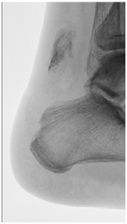

Bones continued

Two types of bone can be seen on a cross section of bone
Trabecular/medullary
Cortical bone

Strength of bone is determined by the orientation of the hydroxyapatite crystals

Loading in different directions will show different stress and failure levels

Avulsion fracture=an unusual fracture where traction forces separate a portion of bone from another part (not typical b/c muscle/tendon should fail first)

How do you tell an old fracture vs a new fracture?
Cortical bone coverage around broken portion

Compression fracture of vertebra picture
When posterior portion of vertebra is complete then you likely aren't dealing w/ a normal compression fracture

Boot fracture=3 point loading will result in fracture at the weakest point along the bone

Types of stress
Shear=opposing directional forces running parallel to each other
Tension=traction along longitudinal shaft
Compression=compression along longitudinal shaft
Bending

Disease of the elderly that effects bone
Osteoporosis=loss of horizontal trabecular in addition to reduced mass w/in medullary bone
What kind of disease?
Old women's disease
When is a woman's bone density the highest? What factors effect it?
26. Ethnicity.
Women of today have lower peak density than women of past generations
Strength training/compaction therapy work well to increase bone density
Most breaks are due to falls, remove objects and wear hip pads to reduce injury
Weak spot on vertebra=endplate
When the body is low on serum Ca, it will pull Ca from the bone mineral reserves

Review from end of chapter-Copy and paste into here
Review on Bone damage
Extrinsic
Infectious agents-after surgery
Chemical factors-overuse of corticosteroids (3 negative effects-reduce immune response, prevents Ca absorption, reduces osteoblasts activity)
Radiation-cancer treatment
Mechanical
Overload
Underload
Fractures
Traumatic
Fatigue
Intrinsic
Metabolic
Osteoporosis
Osteomalacia/rickets
Hypo/hyperparathyroidism
Hyperthyroidism
Vascular
LCP=Legg Caves Perthes
Sheuermann=hunchback old ladies
Osteochondritis Dissecans=decreased bone health due to pathological loss of blood flow
Osteonecrosis=Bone death
Mechanical
Osgood Shlatter=traction apophysitis
Cellular factors
Genetic
OsteoGenesis Imperfecta
Tumors
Osteoblastoma
Osteosarcoma
What 3 fractures take up 90% of the money?
Hip fractures, radius fractures, vertebral fractures


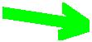

Lecture 5
Wednesday, January 23, 2008
9:16 AM

Cartilage
3 kinds of cartilage
Hyaline cartilage-why is that important? b/c we adjust over it
Smooth, glassy surface
Elastic cartilage-similar to hyaline but contains yellow elastic bundles
Fibrocartilage-filamentous strands containing both type I and type II cartilage
Fx of cartilage on end of bone
Reduce friction, wear
Delays the transfer of forces
Composition
Collagen (mostly type II): provides tensile strength
Water
Provides resistance to compression
Carry nutrients to cells
Cells
Produce collagen and proteoglycans
Destroy collagen and proteoglycans (if needed)
Responds to stress and deformity (are surrounded by stress sensing layer)
Extracellular matrix
Proteoglycans-big, complex molecules forming electronegative balls that repel each other and bring in the water
Gets degraded by loss of function (immobilization)
Takes long time to heal b/c doesn't have a lot of cells
How do you measure cartilage?
Take X-ray and measure joint space
Most big joints should be about 4-5 mm. Knee is the largest
C3 facet~.5 mm
#1 reason for Dr visits=osteoarthritis
Osteoarthritis=degeneration of hyaline cartilage
#1 cause for osteoarthritis is immobilization

Reduction in friction
Cartilage should live as long as you do
Friction is mostly reduced by synovial fluid
What doesn't synovial fluid have in it?
RBCs, but it is mostly the same composition as blood
Very little in each joint but is constantly produced and degraded by synovial cells
Joint capsule will have negative pressure

Elastohydrodynamic lubrication
Lubrication: how does it work?
When we move we squeeze water out of the two surfaces which will ball up and allows the surfaces to not touch (like a sled)
Coefficient of friction=lower than anything humans have made
Why don't bone touch?
Lubricin=a small protein attaches itself to both surfaces that traps synovial fluid (preventing the surfaces from touching when still)

Collagen in bone=type 1 (it is longer than type 2)

Boundary layer=small layer of trapped synovial fluid keeping bone surfaces from touching
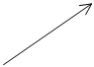

Lecture 6
Friday, January 25, 2008
9:14 AM

Quick review of the anatomy of the joint
X-ray
Bones=white
Capsule=black

Shriveled like a raisin not blown up like a balloon
Blood supply
Good on bones and capsule
None on interjoint space
Capsule=Boundary layer of synovial fluid producing cells

Arthritis
Movement is a great treatment
Not an inflammatory disease
Treated by allopathic medicine by anti-inflammatory medicine (but it isn't an inflammatory problem) and pain reducing agents (which is good b/c it allows people to move)
What is the process of osteoarthritis?
When proteoglycans leak out and water leaves the joint the two bones come closer together
Shock absorption decreases and bone will thicken/strengthen next to the joint (subchondral sclerosis) or will expand the surface area (osteophytes)
The joint capsule will become lax
Geode formation=bone sections may become filled w/ synovial tissue (effected by changes in barometric pressure)
What does it look like on X-ray?
Joint space goes from normal to decreased
Subchondral sclerosis and/or osteophytes
Geode formation

RA
Rheumatoid Arthritis=a soft tissue/synovial disease involving blood in synovial fluid
Will increase bone density whereas OA will decrease bone density

Physiology of synovial cells
When palpating joints and instead of feeling a grape instead of a raisin what could cause that?
Blood in joint (bone fracture/ligament tear), bacterial infection
When a tender/inflamed joint is adjusted why does the sensitivity and swelling dissipate?
The excess fluid is reabsorbed due to control by sympathetic nervous system
Fatty fibrocartilage in the Meniscoids act to keep bones aligned

Cavitation and its effect on the joint
CO2 gas comes out of solution as the surface tension is broken and when the capsule pulls back together and hits the bone then you hear the 'pop'
When the joints begin to pull back together signals are sent back to the cord (the good feeling)
After the cavitation the 15 minute period to allow the gas to get back into solution (people said this was to let the adjustment 'hold')
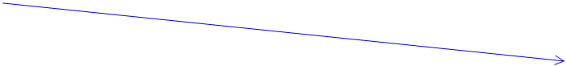
Subchondral sclerosis
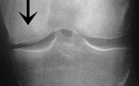

Osteophytes
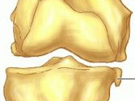

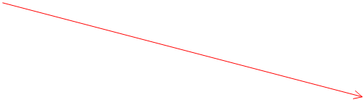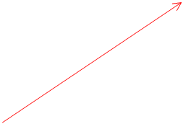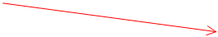

Lecture 7
Wednesday, January 30, 2008
9:17 AM

Biomechanical properties of ligaments and tendons
Always in the same chapter
Only thing they have in common is what they look like and what they are made of
Function is completely different, pathology is completely different

Tendons start out as more parallel but ligaments are more wavy before stress is applied

Ligaments
Ligaments are designed to limit the range of motion to protect joints and orient normal motion
Yellow Ligament=Ligamentum Flava=only stretchable ligament in the body
Once a ligament is lengthened it will destabilize a joint and will begin the process of osteoarthritis
Immobilization of a joint will cause a decrease in diameter of the ligaments of said joint (w/ a small degree of immobilization)
Stimulation or exercise will strengthen and stiffen ligaments but it will not shorten the ligament
Typically damage occurs due to trauma

A graph of a ligament taken to destruction
The toe is the straightening out of a ligament, things are starting to line up
The next part is the elastic portion (linear)
The normal end range of motion is present here
At the end of elastic portion we start to tear fibers (where we get a Grade 1 strain)
No increase of length at this time
Microfailure portion is where Grade 2 strains occur
Major failure will produce a Grade 3 strain (complete failure)

Tendons
Should not fail under normal conditions. The muscle belly should fail first
Classic example is the Achilles tendon failure
Typically a middle age female w/ multiple repeated microtrauma and degeneration
The women wear high heels during the week and then wear something w/ no heel on the weekend
The tendon is shortened during the week and then stretched to a maximum on the weekend
Repeating this multiple times will result in failure
What pathology do we see in tendons?
Tendonitis=inflammation of a tendon
What causes tendonitis?
Repeated microtrauma?-No when studies are done on sore tendons we do not see (microscopically) pro-inflammatory signs in the tendon at the time
Tendonosis=Tear of Sharpie's fibers (connecting the tendons to the bone)

How do we treat tendon and ligament problems?
Unlike bone tendons and ligaments don't change as much as we age
Pregnancy changes the tensile strength of ligaments under the influence of hormonal changes
Diabetes Mellitus-Pt w/ this disorder will have problems w/ tendons and such
Steroids-Tend to eat up tendons, and are worse when directly injected into tendons
NSAIDs: Shows some positive effect by increasing the healing (possibly by speeding up cross fiber formation)
Eccentric exercise-Has shown to be good for tendon injuries
Strain rate=amount of change before failure begins to occur

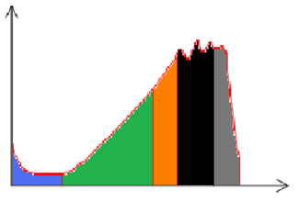

Lecture 8
Wednesday, February 06, 2008
9:14 AM

Muscles

Fx=Movement, Heat production, Shock absorption and protection of joints
Types
Type 1=Slow twitch
Type 2A=Fast twitch
Type 2B=Fastest twitch
What determines what type of muscle things are?
Innervation will allow change
1st thing that happens when start exercising or stopping (atrophy) is neuron branching
You CAN change the % of numbers of fibers and fibers can split so you can-I don't believe this but according to Casper it is true

Types of muscle work and contraction
Static work=Isometric contraction
Dynamic work=
Concentric contraction=muscle shortens in same direction of contraction
Eccentric contraction=muscle gets longer despite contraction in opposite direction
50-80% stronger than concentric
Eccentric loading (bending legs then straightening them)
Myths
Stretching
Why stretch?
To reduce GTO (muscle reflex) tension
Stress relaxation explains why stretching lets one bend more
Nothing is happening to the muscle it just allows the joint to move farther
Does not decrease injury
Muscle training
When you condition a type of muscle (ie type I) you decondition another type of muscle
Inactivity on muscle endurance
1 week 50% decline in aerobic capacity
Exercise and muscle pain
Pain immediately after exercise-unknown source
Delayed onset muscle soreness
24-28 hours post exercise
Soreness and weakness
Source: inflammatory pain from microtrauma (due to eccentric loading)
Pain induced by muscle cramps
Source: neurological
How do you stop cramps?
Contract the antagonistic muscle

Negative effects of immobilization
Joint
Increased rate of glycosaminoglycans
Changes post 8 weeks of immobilization
Joint contracture
Muscles
20% loss in strength per week
Cardio
Disc

Aging
MS systems go downhill after 40

Lecture 9
Friday, February 08, 2008
9:15 AM

Peripheral Nerves
Can be involved in many conditions through altered biomechanics
One of the things to remember about nervous tissue: require lots of blood supply
When arteries enter the nerve they go both directions
No lymphatics for nerves (not picking up extra serum)
Pinch on nerve will create extra pressure in nerve itself
TOS
Costoclavicular, Adson's, Wrights tests for TOS
97-98% of TOS is only neural
Acute
Sensory nerve=numbness (paresthesia)
Muscular nerve=reduced strength (hypotonia)
Chronic
'Pins and needles'
Pain
How do most nerves get injured?
Traction injury (stretching)
This will block the veins leaving the nerves
Example
Disc herniation-nerve has to stretch to get around bulge of disc
May experience pain from posterior disc element innervation or may not
SLR will stretch the nerve root which will exacerbate the pain
Actual nerve fibers are more delicate than the epineurium
Compression
This is what we classically see
Carpal tunnel syndrome: Tinel tap test (70% good)
Compression of median nerve due to multiple factors
3 diseases predominate: RA, Diabetes, Repetitive use
Also: pregnancy
Axoplasmic flow
1st thing effected w/ damage to nerve
Tied w/ almost every nerve disease
The silent killer-disrupted axoplasmic flow
Guinea pigs subluxated purposely
Then look at kidneys in killed subjects over a year
Changes in structure of kidneys but Fx not significantly effected for long time
This was due to changes in axoplasmic flow

Lecture 10
Wednesday, February 13, 2008
9:17 AM

Talking about normal discs

Why do we have discs?
Fx: flexibility, stability, shock absorption/transfer
What structures of the human body doesn't have nociceptors?
Brain, hyaline cartilage of joints, NP of discs

Parts of discs
Nucleus Pulposus
Like toothpaste
High percentage of water, lots of proteoglycans
Cartilage (collagen type II)
5% oxygen content
Deforms more than moves (< 1 mm) in flexion/extension
Surrounded by capsule before AF
Annulus fibrosus
Mostly collagen, high water content
Fibers run at opposing angles to each other
All fibers resists motion w/ compression/distraction
Only half resist motion w/ lateral flexion/extension/flexion/rotation
Vertebral end plates
Starts out as hyaline cartilage but changes to fibrocartilage
Fx: allows nutrient flow from vertebral body to NP (imbibition)

Normal disc aging
88% of disc is water when born
65% of disc is water when 80
Most water is lost in 1st decade
Lots of changes in proteoglycans (decreases a LOT as we age)
AF gets thicker w/ age (loses elasticity)
Color changes
Young: NP translucent, AF white
Old: NP, AF both white
Sizes increase w/ age 5-10% in diameter and 5% in width
Flexibility
The larger the disc the more space the bones can move before they touch
At 5-6 years of age the disc height may be larger than the vertebral bodies (b/c disc grows before vertebral bodies)
In adults C5-6 has a disc 1/3 of the vertebral size which is the largest in the spine
Lordosis/kyphosis measurements: All should be b/t 30-40°
C-spine vertebra are smaller in the front than the back
A reverse curve of the C-spine indicates a disc problem
T-spine vertebra are smaller in the front than the back
L-spine lower vertebra are larger in the front than the back

Why do we have water in the disc?
Non compressible as long as it is contained
What happens when we push on a disc?
The NP flattens out
The AF expands out a little but not much
When you lean to the right what direction does the disc move to?
To the right
What muscles are needed for flexion?
None, the Erector group fires to keep you from falling over but only gravity is required to flex
Most disc herniations in what age group?
20-40 years old

Lecture 11
Friday, February 15, 2008
9:11 AM

Midterm next wed

Fill in blanks, multiple choice
No calculator

Levers strength and weaknesses
Stress curves
Strengths and weaknesses of stuff we are made of (thru pathological discs)

Pathological discs

2 Pathologies we see w/ discs
Herniations
Nucleus won't come out of a hole drilled in the AF even under compression
When NP gets out of its 'home' it swells b/c of inflammation (it is 'self destructing')
2 types
Extruded=disc material comes out of AF and protrudes superiorly
Protruded=disc material comes out and pushes on AF but doesn't make it all the way out (bulging)
Discogram-imaging modality used to ID NP and general disc features (including possible herniations). Also used to create pain in non-painful herniations
Degenerations
Almost every patient
Amount of degeneration doesn't always correlate w/ symptoms

Weak part of the disc/vertebra complex is the endplate
Its thin and has holes in it so it is easy to break
Fx: Provides nutrients to discs via holes bringing in fluid (through inhibition)
Disease that fuses the spine
Ankylosing spondylitis=major risk is weakening of the bone (due to lack of stress/motion)
Cox technique-symptoms resolve before the actual healing of the disc is completed

How do we get herniations/degeneration?
Endplate fracture changes permeability of endplate
pH changes and chondrocytes activity goes down so the NP becomes more liquid
If an existing pathway for exit through the AF is present then we get herniation
If no existing pathway for exit through the AF is present then we get degeneration

Endplate damage is not visible on X-rays or CT

Schmorl's node=extrusion of NP through vertebral endplate into the vertebral body
Present on 50% of population on X-ray
Carrot stick fracture-easily fractured bone

Sciatica and discs-prostaglandins and proinflammatory factors of extruded disc material NOT pressing on the nerve itself
Diversified Disc moves will work on internal derangement bulges but will NOT work on extruded discs
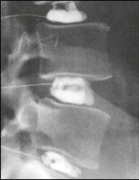
Discogram


Lumbar disc tests

Valsalva-increase in abdominal pressure not allowing the vertebral veins to drain (causing distension and pressure on SOLs)
Dejerine's triad-laughing, coughing, sneezing, bearing down
SLR-stretches pulling the dural root
WLR-confirmation of SLR but more specific 90% vs 70%
Braggard-pulls on dural root but takes hip and hamstring out of the equation
Sickard's-differentiates b/t L4 and L5 (big toe is L5)
Turin's-perform first b/c it is the most sensitive
Milgram's-reproduction of C/C is due to Psoas contraction pulling on the discs

Test 2 Lecture 1
Friday, February 22, 2008
9:19 AM

Facets
Why do we have these?
Limits motion
Affected by RA and OA
What affects discs?
Discogenic spondylosis
Where does the spine have the most motion?
C1 b/c no facets
Cervical spine
Facets face superior at 45 degree angle like a ski jump
Has most motion of the spine
Stair stepping seen on flexion radiograph of facets
Lateral bending is limited by uncinate processes
Most rotation at C1-C2
Thoracic spine
Facets now face much more superiorly
Limits lateral bending
Lumbar spine
Facets now vertical
Limits rotation and lateral bending
8 degree of rotation will tear lumbar disc fibers
3 degree of rotation is allowed by facets
50% of population has facet tropism
Tropism=a differential b/t angle of facets
Most common areas are L5-S1 followed by T12-L1
Also hardest areas to adjust
Facet fractures will occur before an adjustment will cause a lumbar disc herniation
Most lumbar facets aren't oriented 45 degrees on most levels and will vary b/t people
Facet angles will change from birth (0) to learning to walk (major separation) then more change as we age

Lecture 2
Wednesday, February 27, 2008
9:17 AM

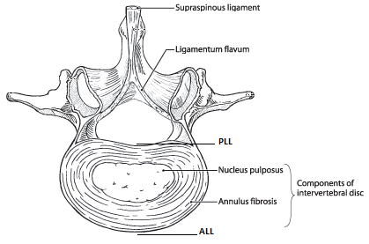

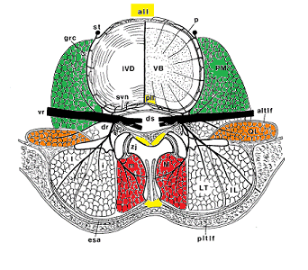

How does the things we talked about work together?

Ligaments and muscles on cross section of disc/paraspinal tissue

ALL
C/S spine
Retains energy from compression forces on spine to elevate the head on the next step
Hyperlordosis-may be due to rear end collision
May rupture and avulse part of disc
T spine
Doesn't do much in this area
PLL
C/S spine
Protects the disc during flexion and rotation
Ligamentum Flavum
High percentage of elastic collagen
Will never be 'loose'
If it is loose it could be caught in the facet joint (as it normally acts as a part of the joint capsule)
Thickens and becomes less elastic w/ age
Majorly damaged ligament in hyperextension/flexion injuries
Supraspinatus Ligament
Primary restriction to hyperflexion

Muscles

Psoas Major
What does this have to do w/ back pain?
It is connected to the spine, disc, vertebra (lateral surface near sympathetic chain ganglion)
When contracted it puts the spine into flexion/extension/lateral bending depending on the position
But always puts compression on the spine (Milgram's test)
Multifidus
Becomes part of the posterior facet capsule and is innervated by the same level
What does it do to the spine?
Extends the spine
Dorsal root loop syndrome (facet syndrome)=irritation of the capsule causing firing of the multifidus bilaterally causing extension of the spine and exacerbation of the irritation of the capsule
A simple adjustment will break this cycle
Obliques
Bumps along top of iliac crest are nodules of these muscles
Are often fired eccentrically

What is your lowest freely movable vertebra?
None of them are freely moveable
Iliolumbar ligament
Starts as muscle and will sometimes turn to bone in old age
Really restricts motion on L5

Cervical spine
Uncinate processes hypertrophy posterior and lateral
Vertebral artery can often be pinched by degeneration easily

Sitting vs standing
Sitting creates more intradiscal pressure vs standing

Lecture 3
Wednesday, March 05, 2008
9:17 AM
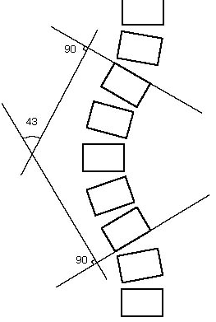

Putting it all together

A common spinal problem we will see: scoliosis

Scoliosis=deviation in spine
Clinically significant at 5-10 degree
Cobb Angle
Find one up from apex that is tipped the most and draw a line from its inferior endplate
Find one down from apex that is tipped the most and draw a line from its superior endplate
Draw perpendicular lines from original lines and measure angle b/t the lines
Don't want to name primary/secondary
Name using major/minor
Risser-Ferguson
Calcification along iliac crest divided into 4 zones (4 being skeletal maturity)

Types
Idiopathic-1% of population
Level pelvis and no sure sign of why scoliosis is present
Structural-can find 'cause' of scoliosis (wedged vertebra or other unlevel platform)
Adam's sign
Non-structural
Antalgic scoliosis
Patient is bending to reduce pain but level eyes
Who gets it?
Females, tall for age, familial predisposition
Confirmation=X-rays
Fullspine 4 view 72090 (AP, Lat, supine bilateral bending)
X-ray of left ante-brachium to determine 'bone age'
How does idiopathic scoliosis happen? 1 theory
Genetic predisposition is present
Then when people hit these growth spurts the front of the vertebra grows faster than the posterior part
This straightens out the AP curves of the spine
This leads to rotation of the vertebra
This now leads to lateral deviation based upon rotation
Other theories
3 inputs to spinal position
Righting reflex (eyes)
Cerebellar (proprioception)
Vestibular

These inputs are getting mishandled by the brain
These people are in the bottom 1/4 of their class (may have behavioral problems)
When they go to college they end up in the top 1/4 of their class

How do we help this?
Proprioceptive training-adjusting sacrum/electrical stimulation/ROM training (Swiss Ball training) 3/wk until Risser Sign of 4
Bones growing faster than cord causes stretching
When this happens the boney canal will bend out creating a smaller distance top to bottom despite the actual length of bone being taller
May also lead to Arnold-Chiari Syndrome

Lecture 4
Friday, March 07, 2008
9:12 AM

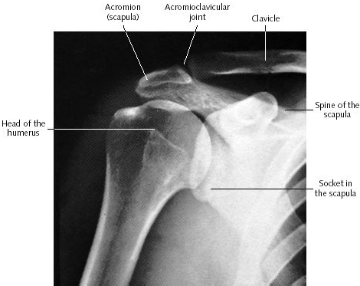

Grading of AC ligament tears
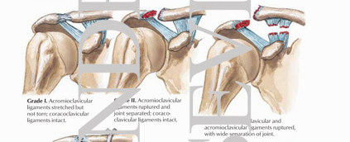
Glenohumeral dislocation
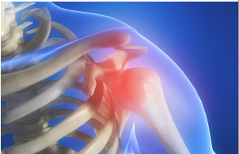
RA Shoulder
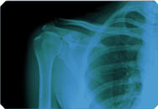
Cervical Rib

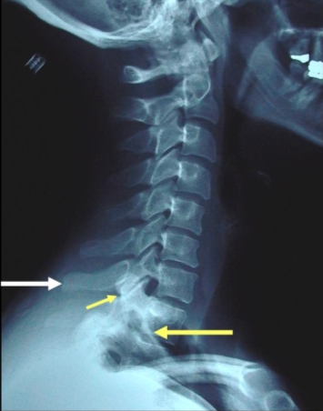
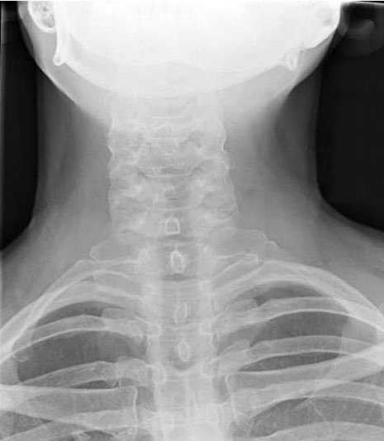

Looking at the big joints of the body

Rest of Tri=Shoulder, hip, knee, foot ankle, gait analysis

Shoulder
2nd most common thing presented in office
Most unstable joint in the body
Anatomy review
4 joints
AC
Easily dislocated by hitting Acromion process
Person will hold humerus up
Commonly affected w/ OA
Ligaments
Grade 1-Acromioclavicular ligament (normal on X-ray)
Grade 2-Trapezoid ligament, coracoid ligament tear (allows separation of clavicle from acromion)
SC
If fixated won't be able to rotate
Humeral Acromion joint
Glenohumeral
Ball and saucer (not ball and socket)
Good: lots of motion
Bad: unstable/no joint stabilization (only soft tissue stabilization)
Separates w/ fall putting arm backwards (worse w/ rotation)
Typically inferior dislocation
Person will have arm straight down
Rarely affected w/ OA
Shoulder injury is 3rd most common complaint after whiplash

Bursas-may develop bursitis due to problems
Most common shoulder complaint
Supraspinatus muscle-has avascular portion near insertion
Tendon will get compressed by Acromion process
Long head of the biceps tendon
Holds the humerus inferior
Travels thru the joint capsule (and may be affected w/ RA)
May be eaten away w/ RA and could lead to superior placement of the humerus
Calcification of soft tissue
Change in vasculature leads to change in pH
Which precipitates the Ca in solution
Holding arm out and the force upon the bone is about half of the body weight
Adding anything to the end of the moment arm can easily increase the force beyond gravity
Major differences b/t left vs right arm is lymph drainage
May show problems w/ cervical rib
Major pump for lymph is diaphragm



Lecture 5
Wednesday, March 12, 2008
9:18 AM

The Hip

Major disorders
Osteoarthritis
Most will be idiopathic
Hip fractures (typically we will see the results)
After 'replacement' don't do side posture/adduct hip
95-98% of fractures occur as Subcaptial Fracture
Fatigue of gluteus medius is commonly a contributing factor w/ sedentary fractures
Avascular necrosis
Kids-Legg Caves Perthes

Basic Biomechanics
Angles (coxa vara < normal, coxa valga > normal)
Femoral shaft angle
Angle formed by line thru neck and shaft
125°~normal (should be equal bilaterally)
Coxa valga angle is under more stress than coxa vara or normal
Femur angle
Changes from birth (40°) to a statistical normal of 15°
A greater than normal femur angle may have a 'toe in' appearance under gross examination due to altered femur development (to keep the hip stable)
Can palpate prone on hard table (to stabilize pelvis) and measure distance b/t greater trochanter and table bilaterally
Leg length inequality
'Tall' leg is more likely to get arthritic change
Anatomy
Tension band
ITB forms tension band to reduce tensile loading (keeping everything under compression)
Gluteus medius
Holds body up during Trendelenburg test
1/3 of body weight is below hip
When standing a 150 lb person has 50 lb thru each hip
When lifting 1 leg 450 lb is now the force being put thru supporting hip
Ball and socket design (but larger cup and more stable than shoulder)
Harder to dislocate in comparison than shoulder
Hard time to heal fractures b/c it is w/in the capsule and auxiliary blood supply does not form
Ligaments
Very strong
Tighten as the hip rotates
Arthritis
How do you test?
Compress and move
Faber=elevate leg, place on knee, then compress before putting down and press posterior

Hip pathology
Relieve pressure on bad hip by carrying weight on side of bad hip (causes a shift in the center of gravity) or if using a cane use it on the opposite side

Knee
Femur angle
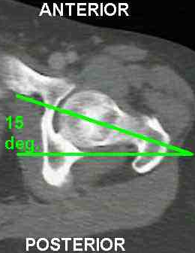

Lecture 6
Wednesday, March 19, 2008
9:18 AM

The Knee

#1 joint outside of spine to develop osteoarthritis
Uniqueness about the knee
Ligaments inside knee (ACL/PCL)
At end of 2 longest levers of the body (highest forces for the body)
Largest joint in the body (surface area)
Most synovial fluid w/in joint (still only 5 ml)
Has meniscus and synovial
Made up of 4 joints
Fibula/tiba=1/6 of stress of knee
Has patella (sesamoid bone)
Increases moment arm of muscles
Decreases tension across the joint
Has thickest cartilage (highest stress in body)
Can be seen in 'sunrise view'
Tracking problems may develop due to asymmetrical growth of patella
Lateral knee X-ray taken at 30° flexion to put patella next to femoral condyle to see size of articular cartilage
When going from 90° to 120° we decrease the surface area and consequently double the stress applied to the patella
Fracture is fairly common
Patella joint is first
Ligaments of the knee that are commonly injured and tested
ACL
Unique b/c inside the capsule
Provide a lot of stability
Test by pulling the tibia forward (Lachman's test or Anterior drawer)
Rupture leads increased edema
Highly innervated (one of the most important proprioceptive inputs of the lower leg)
PCL
Unique b/c inside the capsule
Provide a lot of stability
Test by pushing the tibia posterior
Sag Sign-both legs bent to about 30 degree and examine contour of the knee, if positive the tibia will sink
Rupture leads increased edema
MCL
Large and connects to the meniscus and tibia
Most commonly injured b/c people get hit from outside in
LCL
Small and connects to the fibula
Meniscus
Intermeshing fibers will connect to MCL
Only blood supply to outer portion of meniscus
No innervation so no pain in injuries
Pain at the joint line is major sign of tear
Ortho tests
Apley’s Compression Test-prone push down then rotate lat and med
McMurray’s Test-pt supine knee flexed palpate eyes of knee, clicking from plica
Bounce Home Test-supported drop knee into extension
Steinman’s Test -pain from meniscial attachment travels w/ tibia

Fx of meniscus
Shock distribution

Helps control and direct tibia and femur movement (Apley's compression test)
Interosseus membrane exists b/t fibula and tibia
Lateral Knee X-ray
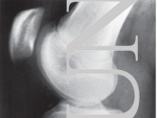

Sag Sign
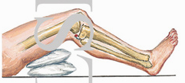

Lecture 7
Wednesday, March 26, 2008
9:17 AM

Ankle
Lateral ankle sprain is #1 injury site
High site for fractures
Uncommon site of arthritis
PA/AP view is most common to see bone problems in
Will see fracture of malleoli and see Talar Osteochondritis Dissicans
Allows for viewing of soft tissue swelling
Lat view is where you see 'heel spur'
Primary function is to flex and extend (extension is most stable but more likely to fracture vs flexion) (flexion is very unstable position and high likely hood of ligamentous tears

Sprains
Most common when in flexion
Inversion sprain (roll ankle out) tearing fibulotalar ligament
Grade 1 not bad
Grade 2/3 lead to ankle instability
High ankle sprain (foot hyperextends and pronates)
May tear into Syndesmosis b/t tibia and fibula and require long healing time
Typically tears the anterior tibial-fibial ligament
May lead to OA of the ankle

Plantar fasciitis
Pain will occur in the morning b/t Calcaneus/Navicular and medial cuneiform
Typically develops b/t 30-50 or earlier w/ activity
Settling of the arch w/ less support of muscles
Tx:
Arch supports (will require people to wear continually)
Preventative='wear your boots to bed' (keep toes extended)
Talus
Unique factoid: one of few bones w/ no muscle attachment
2nd most common site of Osteochondritis Dissicans

Foot
Very complicated (no such thing as a perfect foot)
Lisfranc joint=b/t cuneiforms and metatarsals
2nd metatarsal is site of most stress fractures
When you extend the knee
Talus=screws down the bones of the foot to make a level for the transmission of forces
Supination of the foot turns it into a long lever
Eversion=medial rotation at the ankle joint
Pronation=medial rotation of the foot/ankle complex (more motion eversion)
Inversion=lateral rotation at the ankle joint
Supination=lateral rotation of the foot/ankle complex (more motion than inversion)
Hallux Valgus=deviation of the big toe starts and is made worse by pull on flexor/extensor hallucis musculature (may lead to 'bunions')
Bunions 95% come from women wearing high heels
Higher the heels=greater incidence of knee arthritis
Path of weight transfer w/in the foot
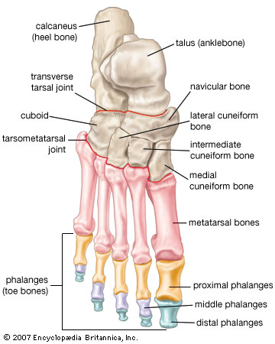

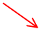

Lecture 8
Friday, April 04, 2008
7:05 AM

Everyone's Sacrum is fused to the ilium

Lecture 9
Friday, April 04, 2008
9:27 AM

Components of Subluxation
Physical
Neurological
Altered biomechanics of a joint effect the Fx of the joint which affects: muscle, neurons, vasculature associated w/ it
Most important part
Neurological: temp changes, muscle tension, capsular swelling
Osteoarthritis part of subluxation
Within 4 weeks of motion fixation we develop arthritic changes
Find w/ motion and static palpation
Complications
Neurological: facilitation, central sensitization
Basic science research related to chiropractic spinal adjusting: the state of the art and recommendations revisited
Stud in 02/06 in JMPT
Fixation
Synovial membrane entrapment
'Scar tissue' in joint capsule-gets broken up by adjustment
Erector Spinae contraction
Capsular swelling-decreases surface tension (was negative but now positive due to swelling of joint)
What makes the spine stable?
Muscles-increase stabilization of the spine 2 fold
Firing is decreased 85% after 10 minutes of vibration leading to decreased stability
Firing is increased due to mechanoreception input to the cord
10 seconds of flexion diminishes mechanoreception afferentation
Neutral zone
The area of a graph of the stability of the spine which shows lower stability
Apparently where adjustments work best
Do you need cavitation?
Maybe no studies prove either way
Is speed more important that cavitation?
Maybe some theories suggest this but no studies can confirm
MUA
Use a general anesthetic to relax the body and especially the surrounding tissue to help the adjustment work

Final Review
Wednesday, April 09, 2008
9:18 AM

Final

All objective no essay
Mostly non cumulative but some stuff splits over

Mostly spine and spinal biomechanics
Anatomy
Shapes of vertebra, discs, facets (segments)
Normal curves
Pathology=idiopathic scoliosis/scoliosis
Kinds/causes
Ligaments front to back
How, what Fx
Muscles
Multifidus
Psoas
Obliques
Workings of the joint
Especially spinal joints (capsules/nerve supply to facet)
Stresses on spine
How to lift how not to lift?
Lumbar motion is highly variable b/t segments and b/t people
Anteversion Angle=why we rotate the foot 15 degrees inward when we take a femur X-ray

Major joints of the body (What's unique)
Shoulder
Ball and socket
Neuro and muscular control
Soft tissue type injuries
Hip
Ball and socket
Stable
Mostly bone and joint injuries
OA, fractures
Not as much musculoskeletal
Angles (significance, change, disease of change)
Knee
Hinge joint
Patella femoral joint is highest stress point
Lots of injuries
OA-lots
Biggest joints
4 different joints
Most of injuries are soft tissue (ligament/meniscus)
Foot
No one is normal or all normal
Long lever vs bag o bones
Plantar fasciitis
Tendonitis
Bunions
Ankle
Stable joint
Lots of strong ligaments
Lots of stress
Most common sports injury=inversion sprain ankle
High vs classic inversion sprain
Fractures
Closed (high ankle or fracture) vs open (lateral tibiofibular ligament) pack and its effects
What are you going to see
1 Closed pack position for each joint
When most joint surfaces are closest together
Ankle=full dorsiflexion
Shoulder=full abduction
Elbow=full extension
Open pack position
Every position but closed pack
Gait
What happens to knees and hips during walking
Femoral shaft angle and its effect on gait
Muscle actions
How often?
How work?

